

newgarageopener.com
new2025modelgaragedooropeners.com,

NEW 2025 YEAR MODEL GARAGE DOOR OPENERS
WE OUTSELL THEM ALL. 47 YEARS IN BUSINESS IT’S ALL BECAUSE OF YOU, THANK YOU.
GENIE CHAMBERLAIN LIFTMASTER
CALL US
323-270-5387 310-915-4151 818-351-3131 562-506-1384

New Genie 2025-year model garage door opener for sale and on sale starting at $660.00 installed with battery backup, 2 remote controls, balancing your garage door, tax and 47 years of professional garage door opener installations.
Call me Joseph Lucey and set up your appointment today.

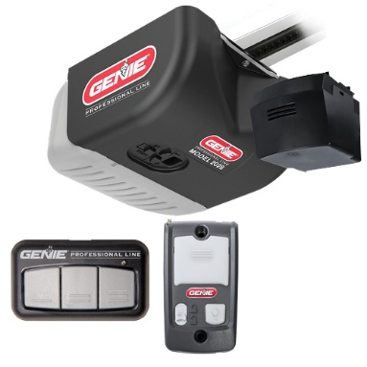
FAST AND EASY APPOINTMENTS
323-270-5387

- If I purchase a new opener, will the battery come in the box?" YES
- Is the battery backup replaceable? YES
- Will a generic battery work? YES
- Can a battery backup be added to older Genie openers? NO
- How long will the battery last? 5 TO 7 YEARS
- How to know when to replace the battery? YOU’LL HEAR A BEEP EVERY 5 MINUTS
- How many times will the battery backup operate the garage door? AT LEAST 50 TIMES
- Will the other garage door opener features work under battery power? YES, EXCEPT FOR THE LIGHTS THEY WON’T COME ON.
- In the event of a power outage, will the operating speed of the opener change?" YES, THE GARAGE DOOR OPENER OPERATS AT A SLOWER SPEED.
- If someone has more than one door on their garage, do they have to have a BBU on every door?" YES, IF YOU’RE BUYING A NEW GARAGE DOOR OPENER IN CA.

2025 Model Belt Drive Genie 750 1-1/4 HP Garage Door Opener with Battery Backup $770.00 installed including tax and installation
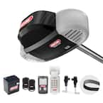
The Belt Drive 750 belt drive garage door opener is an ultra-quiet garage door opener with a steel-reinforced belt, making it the ideal choice for homeowners where sound could be an issue. This garage door opener has a powerful DC motor. This Genie garage door opener features an integrated battery backup. That battery backup will power the garage door opener for up to 50 cycles when the main power is out. This transition from home power to running on the battery happens instantly when the main power is out. Like all Genie garage door openers, the StealthDrive 750 comes equipped with Intellicode rolling code technology that prevents unauthorized persons from opening your garage door. The Genie garage door safety sensors ensure your family’s safety with an infrared beam of light across the door opening.
- 1 1/4 HPc DC motor will smoothly lift a sectional garage door up to 7' in height and up to 500 lbs.
- The integrated backup battery operates this garage door opener when your power goes out up to 50 cycles from initial power failure.
- Keep your home safe with state-of-the-art security of Genie Intellicode changes the opener's access code when the remote is used.
- HomeLink + Car2U integration comes standard, no additional hardware required (Genie Exclusive)
- Safe-T-Beam system keeps your pets and family safe by reversing the closing door if anything passes through the beam.
- Model 7055-TKV

CALL 323-270-5387

Need replacement parts for a Genie Garage Door Opener?
We have them on our fully loaded service trucks.

Belt Drive Connect Model 7155-TKV Smartphone-Controlled Ultra-Quiet Strong Belt Drive Garage Door Opener, Battery Backup - Compatible with Alexa & Google Assistant
$840.00 installed including tax and installation
We also service, oil and balance you garage door as part of our installation, so your new garage door opener works as smoothly as possible.
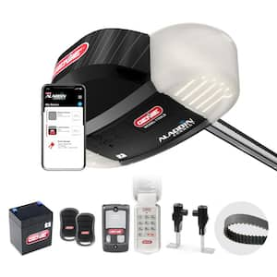
The integrated Aladdin Connect Wi-Fi smartphone technology allows your garage door to be part of your smart home, while app alerts keep you in control and your garage secure. The Genie Aladdin Connect smartphone app is free and allows you to set up virtual keys to individual users through their own app, and is compatible with Alexa, and Google Assistant. The Belt Drive Connect smart garage door opener has a powerful DC motor with Genie Sense technology standard. For extra safety and added convenience, this Genie garage door opener features an integrated battery backup. The battery backup will power the garage door opener for up to 50 cycles when the main power is out. The Belt Drive Connect includes many accessories for safety and convenience. Included are two pre-programmed 3-button garage door opener remotes, a wireless keypad and a multi-function wall console that provides you with a light control button and a vacation lock. The Genie Safe-T-Beam garage door safety sensors ensure your family’s safety with an infrared beam of light across the door opening. This Genie garage door opener is packed full of features that allow you to open, close and monitor your garage door safely. For use on residential sectional garage doors only.
- STRONG AND QUIET: The Belt Drive Connect smart garage door opener has a 1 1/4 HPC DC Motor that is paired with a steel-reinforced belt drive making this garage door opener perfect for garages that are attached to bedrooms and/or nurseries
- SMART GARAGE SYSTEM COMPATIBLE WITH ALEXA & GOOGLE ASSISTANT: The built-in Aladdin Connect technology allows you to monitor, open and close your garage door from anywhere with your smartphone. New features allow you to use the Stealth Drive Connect smart garage door opener to operate the garage door with voice control using the Aladdin Connect custom skill for Alexa or Google Assistant
- BATTERY BACKUP INCLUDED: The Stealth Drive Connect garage door opener comes equipped with a battery backup that allows for the garage door opener to be used when the primary power is out. This feature provides up to 50 cycles from the initial power failure.

CALL 323-270-5387

Need replacement parts for a Genie Garage Door Opener?
We have them on our fully loaded service trucks.

Signature Series 2 HP Premium Screw Drive Garage Door Opener Wi-Fi Enabled with Battery Backup

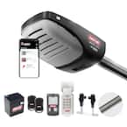
$915.00 installed including tax and installation
We also service, oil and balance you garage door as part of our installation, so your new garage door opener works as smoothly as possible.
The Signature Series premium screw drive smart garage door opener has an ultra-quiet 2 HPc DC motor that provides the ultimate combination of power and speed. The integrated Aladdin Connect Wi-Fi smartphone technology allows your garage door to be part of your smart home. The Genie Aladdin Connect smartphone app is free and allows you to set up individual users through their own app and set up virtual keys to operate your garage door opener. It also has a 140-Volt DC motor paired with a maintenance-free direct screw drive system that increases strength, power and provides unmatched durability, making it the ideal choice to open the heaviest garage doors. For extra safety and added convenience, this Genie garage door opener features an integrated battery backup. That battery backup will power the garage door opener for up to 50 cycles when the main power is out. You will also enjoy the added conveniences of 2 pre-programmed 3 button remotes and a wall control panel with an independent light button and vacation lock for added security. The Genie Safe-T-Beam garage door safety sensors ensure your family’s safety with an infrared beam of light across the door opening. This premium screw drive garage door opener is made with an enclosed rail design for safety and many years of reliable operation.
The included backup battery operates this garage door opener up to 50 times after your power goes out
- Exclusive Genie premium screw drive technology designed to lift heavy garage doors quickly
- Limited lifetime warranty on drive components
- Aladdin Connect smart home technology built-in: your smartphone becomes your garage door opener remote, works with Amazon Alexa and Google Assistant
- Accessories included; x2 pre-programmed remotes, a multi-function wall console control panel with vacation lock and light control button and safe T-Beam garage door sensors
- HomeLink + Car2U integration comes standard, no additional hardware required (Genie exclusive)
- Genie intellicode secures your home with rolling-code technology
- Safe T-Beams garage door safety sensors come standard to keep your family and pets, safe with infrared technology
- Genie dual-frequency remotes operate on both 315 and 390 MHz to minimize interference and improve your garage door opener remote performance
- For use on sectional or 1 piece garage doors
- Model 4063B-TKV

CALL 323-270-5387

Need replacement parts for a Genie Garage Door Opener?
We have them on our fully loaded service trucks.

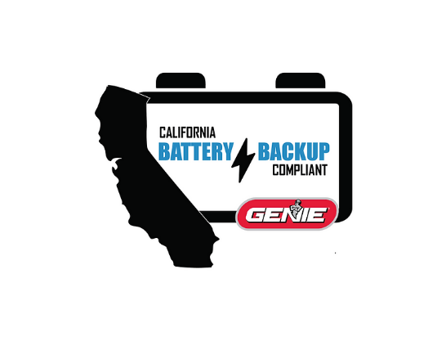

California Residents
In accordance with California State Law SB-969, all installed garage door openers in the state of California must have a battery backup as of July 1, 2019. Genie offers a complete line of garage door openers that meet this requirement.

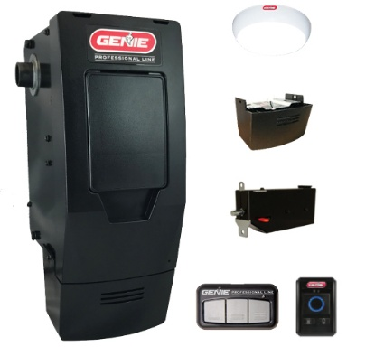
Battery Backup Included on these 2025 model genie garage door openers:
Professional Models (Dealer installed):
- 6170H-B, 6070H-B, 4164H-B, 4064H-B, 4124H-B, 3124H-B, 3024H-B, 3120HL-B, 3120H-B, 2128B, 1128B, 2028B, 1028B
DIY / Retail Models:
- StealthDrive 750 (7055), Chain Drive 750 (7035), StealthDrive Connect (7155), SilentMax LED (7155L), Wall Mount (6172)
Battery Backup available as an add-on:
Professional Models (Dealer installed):
- 6070, 4164, 4124, 3120, 4064, 3064, 4024, 3024
DIY / Retail Models:
- Mach Force (4062), Mach Force Connect (4063), SientMax 1200 (4042), Silent Max 1000 (3042), Chain Max 1000 (3022)

WE OFFER GARAGE DOOR OPENER REPAIR ON
ALL GENIE NEW AND DISCOUNTINUED MODELS
CALL THIS NUMBER FOR SERVICE REPAIR 323-270-5387
GARAGE DOOR REPAIR
We repair all makes and models of garage door openers in Los Angeles, Ca. County, San Fernando, and most of Orange County. Genie, Wayne Dalton, Automatic Doorman, Stanley, Blue Max, Chamberlin, Crusader 202ss, Chief, Sioux, Moore O Matic, Vemco, Ambassador Linx, Chain drive, Screw drive Belt drive. We also replace broken garage door springs, sectional garage door springs, torsion springs Holmes springs, King Hardware, American hardware and springs, Tavart, rankin, Apex.

NEW 2025 MODEL GARAGE DOOR OPENERS ON SALE NOW
Chamberlain Belt Drive, Belt Drive Garage Door Openers

Chamberlain

1/2 HP Smart Belt Drive Garage Door Opener with Battery Backup

This is a GREAT garage door opener $740.00

Installed with 2 remotes including tax and installation.

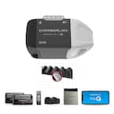
Chamberlain is the most trusted brand of garage door openers, designed with the safety of your home and family in mind. For the 70% of homeowners who use their garage door as the main entry to their home, a power outage can become not only an inconvenience but a major safety and security issue. The B2211T comes with integrated battery backup to allow you to safely get in and out of your garage even when the power is out and the ultra-quiet operation ensures for comfortable living spaces near the garage. Additionally, integrated myQ technology lets you control, secure and monitor your garage from the myQ app - anytime, from anywhere.

Highlights
- Quiet operation: an ultra-quiet DC motor and soft start/stop smooth operation ensures for comfortable living spaces near the garage
- Battery backup: open/close the garage door even when power is out
- Smartphone control: download the myQ app and follow the steps to connect your new garage door opener so you can control, secure and monitor the garage from your smartphone - anytime, from anywhere
- Next generation garage technology: improved Wi-Fi connectivity and enhanced memory to support new myQ features and solutions
- Integrated bluetooth technology: reduces setup time and makes it even easier to connect to the myQ app, other myQ devices and smart home technology solutions
- Works with Amazon key in-garage delivery: link to Amazon key in the myQ app for secure and convenient in garage delivery of groceries and Amazon packages
- Trusted security: security+ 2.0 technology provides unmatched encryption (100 billion codes)
- Additional assurances: 6-year motor warranty, 5-year belt warranty, 1-year parts warranty, 1-year accessories warranty
- Chamberlain residential garage door openers are designed to operate with standard 7-foot-high garage doors, but if you have a taller door we could get rails up to 10 feet.

Chamberlain Chain Drive, Belt Drive Garage Door Openers

Chamberlain

1/2 HP Smart Chain Drive Garage Door Opener with Battery Backup

This is a GREAT garage door opener $755.00

Installed with 2 remotes including tax and installation.

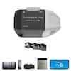
Chamberlain is one of the most trusted brand of garage door openers, designed with the safety of your home and family in mind. For the 70% of homeowners who use their garage door as the main entry to their home, a power outage can become not only an inconvenience but a major safety and security issue. The C2212T comes with integrated battery backup to allow you to safely get in and out of your garage even when the power is out, and integrated myQ technology lets you control, secure and monitor your garage from the myQ app - anytime, from anywhere.

Highlights
- Smartphone control: download the myQ app and follow the steps to connect your new garage door opener so you can control, secure and monitor the garage from your smartphone - anytime, from anywhere
- Works with key by amazon: link to key by amazon in the myQ app for secure and convenient in garage delivery of groceries and amazon packages
- Next generation garage technology: improved Wi-Fi connectivity and enhanced memory to support new myQ features and solutions
- Integrated Bluetooth technology: reduces setup time and makes it even easier to connect to the myQ app, other myQ devices and smart home technology solutions
- Quiet operation: an ultra-quiet DC motor and soft start/stop smooth operation ensures for comfortable living spaces near the garage
- Battery backup: open/close the garage door even when power is out
- Trusted security: security+ 2.0 technology provides unmatched encryption (100 billion codes)
- Additional features: the opener also comes with two 3-button remote, push-button door control inside the garage and safety sensors
- Additional assurances: 6-year motor warranty, 1-year chain warranty, 1-year parts warranty, 1-year accessories warranty
- Chamberlain residential garage door openers are designed to operate with standard 7-foot-high garage doors, but if you have a taller door we could get rails up to 10 feet.

Chamberlain Belt Drive, Belt Drive Garage Door Openers

Chamberlain

3/4 HP Smart Belt Drive Garage Door Opener with Battery Backup

This is a GREAT garage door opener $855.00
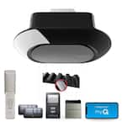
Installed with 2 remotes including tax and installation.

The garage is a place for all your home’s storage. It’s where you keep your tools, sports equipment, toys, and it’s a place where you keep some of your most expensive positions are stored such as your car. Unleash your garage’s full potential with the B4613T Chamberlain Garage Door Opener powered by myQ.

Highlights
- Smart control: manage your garage door, monitor activity, and ensure your property is secure from anywhere using the myQ mobile app
- Integrated LED lighting: advanced, motion-activated lighting targets 1,000 lumens of illumination towards high-traffic areas of the garage, providing optimal visibility, safety, and utility
- Whisper-quiet operation: open and close your garage door with minimal noise, thanks to an ultra-quiet DC motor and belt drive system, ensuring peaceful garage surroundings
- Open and close your garage door with minimal noise, thanks to an ultra-quiet DC motor and belt drive system, ensuring peaceful garage surroundings
- Seamless package and grocery delivery: with myQ in-garage delivery partners, enjoy hassle-free deliveries into your garage
- Simple installation and setup: say goodbye to traditional paper manuals and hello to BILT intelligent instructions - providing easy, step-by-step guidance in 3D, so getting set up is a breeze
- Trusted security: cutting-edge Security+ 2.0 encryption generates over 100 billion unique codes to ensure only your remote opens the garage door
- Bluetooth for easy connectivity: integrated Bluetooth technology reduces setup time and makes it easy to connect and start using the myQ app
- Chamberlain residential garage door openers are designed to operate with standard 7-foot-high garage doors, but if you have a taller door we ca get you a rail up to 10 feet.



Liftmaster Garage Door Opener Model 87504-267 $
Secure View™ Ultra-Quiet Belt Drive Smart Opener with Camera, LED Corner to Corner Lighting™ and Battery Backup
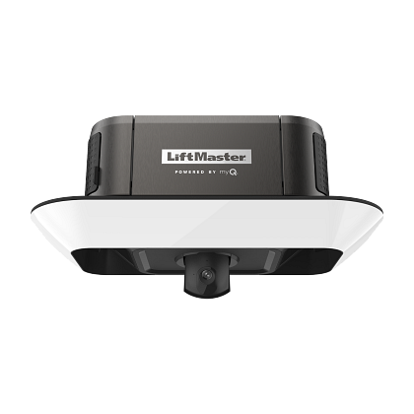
- Built-in camera adds video and 2-way audio communication to the myQ® app.
- Control, secure and monitor the garage with the myQ app- anytime, from anywhere.
- 360° light ring uniformly brightens every corner of the garage with 2,000 lumens of long-lasting LED light.
- Battery backup lets you get in and out when the power is down.
- Ultra-quiet DC motor and strong belt drive system ensures for comfortable living spaces near the garage.
- Works with Amazon Key for for convenient and secure In-Garage Delivery of Amazon packages and groceries – watch deliveries happen in real-time.
- myQ Diagnostics in the myQ app provides real-time insights for your garage door via the Health Report. Receive alerts and error codes in the app if an issue arises and connect with a professional for services if needed.

Warranty
- Accessory Warranty: 1 Year
- Belt Warranty: Lifetime
- Motor Warranty: Lifetime
- Parts Warranty: 5 Year

Liftmaster Garage Door Opener Model 87802 $
Chain Drive Smart Opener LED Corner to Corner Lighting™ and Battery Backup

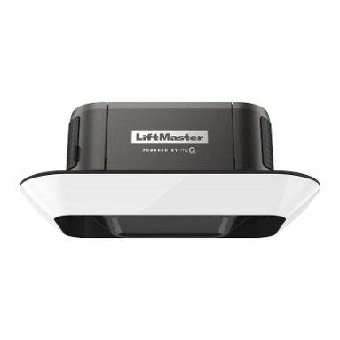
Liftmaster Model 87802
Heavy Duty Chain Drive Smart Opener with LED Corner to Corner Lighting™ and Battery Backup
- Heavy duty chain drive lifts the heaviest garage doors.
- Control, secure and monitor the garage with the myQ® app anytime, from anywhere.
- 360° light ring uniformly brightens every corner of the garage with 2,000 lumens of long-lasting LED light.
- Battery backup lets you get in and out when the power is down.
- Works with Amazon Key for for convenient and secure In-Garage Delivery of Amazon packages and groceries.
- myQ Diagnostics in the myQ app provides real-time insights for your garage door via the Health Report. Receive alerts and error codes in the app if an issue arises and connect with a professional for services if needed.​

Warranty
- Accessory Warranty: 1 Year
- Motor Warranty: Lifetime
- Parts Warranty: 5 Years
- Chain Warranty: 5 Years
5 Years

These are older models and model numbers of Genie garage door openers we service.
Alliance, Blue Max, Excelerator, Genie Pro, Hercules, Intellicode, Legacy, Overhead Door, Pro Max, Signature Series, Stealth, Chamberlain, Craftsman, Estate Series, Formula I, Sears, Security +, Whisper Drive, Vemco, Allister, All-O-Matic, Allstar, Challenger, Pulsar, Delta 3, MegaCode, Moore-O-Matic, Overhead Door, Crusader, Chief, Soiux, Moore-o-matic, crusader XL, Crusader 200ss, Crusader 202, crusader 202ss, crusader 2000, crusader 2002ss, crusader, 800, GG1950, 1810, GS900, 920, 940, 975, GS810, 810A, 815, 840, GS210, 250, CHAIN DRIVE, SP99, SP129, SP229, CH125, 130, LD100, 500, 100A, 550A, LAD125, 555, CM6000, 6000A, CM60, 70, 80, 60S, 70S, 80S, PMX60, 70/80, SCREW DRIVE, GS980, 9800, 880, 8800, GS820, 8200, 720, 850, 800, PRO82, 98, 88, 90, PRO83, 93, PRO88S, 98S, CM7500, 8500, 7500S, 8500S.
Genie 1950, Genie 1810, GS900, Genie 920, Genie 940, Genie 975, GS810, Genie 810, Genie 815, Genie 840, GS210, Genie 250, CHAIN DRIVE, SP99, SP129, SP229, CH125, Genie 130, LD100, Genie 500, Genie 100A, Genie 550A, LAD125, Genie 555, CM6000, 6000A, CM60, Genie 70, Genie 80, Genie 60S, Genie 70S, Genie 80S, PMX60, Genie 70, Genie 80, SCREW DRIVE, GS980, Genie 9800, Genie 880, Genie 8800, GS820, Genie 8200, Genie 720, Genie 850, Genie 800, PRO82, Genie 98, Genie 88, Genie 90, PRO83, Genie 93, PRO88S, Genie 98S, CM7500, Genie 8500, Genie 7500S, Genie 8500S, SD Series, Genie 9500, Genie 9000, Genie 8000, Genie 2500, Genie 5000, GXL, GX, G Series, Genie 9500, Genie 9000, Genie 8000, Genie 2500, Genie 5000, Genie 10000,
Genie garage door openers, Intellicode garage door openers, Stealth garage door openers, Blue Max garage door openers.
Genie 1950, Genie 1810, GS900, Genie 920, Genie 940, Genie 975, GS810, Genie 810, Genie 815, Genie 840, GS210, Genie 250, CHAIN DRIVE, SP99, SP129, SP229, CH125, Genie 130, LD100, Genie 500, Genie 100A, Genie 550A, LAD125, Genie 555, CM6000, 6000A, CM60, Genie 70, Genie 80, Genie 60S, Genie 70S, Genie 80S, PMX60, Genie 70, Genie 80, SCREW DRIVE, GS980, Genie 9800, Genie 880, Genie 8800, GS820, Genie 8200, Genie 720, Genie 850, Genie 800, PRO82, Genie 98, Genie 88, Genie 90, PRO83, Genie 93, PRO88S, Genie 98S, CM7500, Genie 8500, Genie 7500S, Genie 8500S, SD Series, Genie 9500, Genie 9000, Genie 8000, Genie 2500, Genie 5000, GXL, GX, G Series, Genie 9500, Genie 9000, Genie 8000, Genie 2500, Genie 5000, Genie 10000.
Genie BELT DRIVE
GPS1200-IC - GPS700-IC
PRO706-BC - PRO0800-BC
PRO1000-BC - PRO1200-BC
Genie EXCELERATOR
PRO99-2IC - CMD9900-IC - ISD990-2 - ISD1000
Older Model Genie Screw Drive Garage Door Openers

Genie 400, Genie 401, Genie 404, Genie 450, Genie 459, Genie 8600, Genie PRO,
GS980, 9800, 880, 8800 - GS820, 8200, 7200, 850, 800
Genie PRO82, Genie 98, Genie 88, Genie 90 - PRO83/93 - PRO88S/98S
CM7500, CM8500, CM7500S, CM8500S - G-CL SERIES - IS SERIES
CSD 0706 - CSD 0800 - ALC 60 - 70 - 80 - 75-IC - 85-IC RCD 225 - 250 - 500 - 550
CM7600-IC - CM8600-IC - PRO95
404 - 450 - 409 - 459 - 419A - 420 - 414 - 419 - 800
8200 - 8800
SD SERIES - 9500, 9000, 8000, 2500, 5000
GXL/GX/G SERIES - 9500, 9000, 2500, 5000, 10000

Older Model Liftmaster and Chamberlain Garage Door Openers.
Liftmaster, Chamberlain, Sears, Craftsman and some Wayne Dalton garage door operators are all the same they are just boxed under different names with different model numbers.
Liftmaster 3800, 3850,3840,3595, 3585, 3280, 3275, 3265, 3245, 3240, 3255, 3130, 1355, 1345.
Chamberlain WD822ks, Chamberlain WD822kls, Chamberlain DD610s, Chamberlain DD612s, Chamberlain DD612kls, Chamberlain PD420, Chamberlain PD420-2, Chamberlain PD460-2k, Chamberlain PD460-2, Chamberlain PD422D, Chamberlain PD432-D.

